H.T No
Regulations:
A20

Sreenidhi Institute of Science and Technology
(An Autonomous Institution)
Code No: 8AC42 Date: 12-July-2021(FN)

B.Tech I-Year I- Semester External Examination, July-2021 (Regular)
ELECTRICAL CIRCUITS AND NETWORK ANALYSIS (ECM)

Time: 3 Hours Max.Marks:70

Note: a) No additional answer sheets will be provided.
b) All sub-parts of a question must be answered at one place only, otherwise it will not be valued.
c) Missing data can be assumed suitably.

ANSWER ANY 5 OUT OF 8 QUESTIONS. EACH QUESTION CARRIES 14 MARKS.

Bloom's Cognitive Levels of Learning (BCLL)

Remember | L1 | Apply | L3 | Evaluate | L5
Understand | L2 | Analyze | L4 | Create | L6

 |  |  | BCLL | CO(s) | Marks
1. | a) | In the below circuit, find the Current supplied by the voltage source using reduction technique.  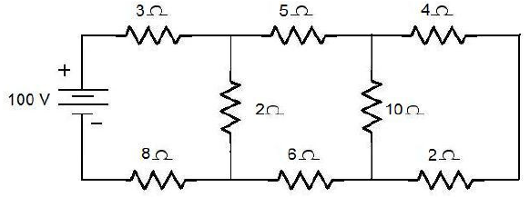 | L4 | CO1 | [7M]
 | b) | State and explain the Kirchhoff’s laws. | L2 | CO1 | [7M]
2. | a) | Find the currents i_{s},i_{c} and i_{L} in the below network.  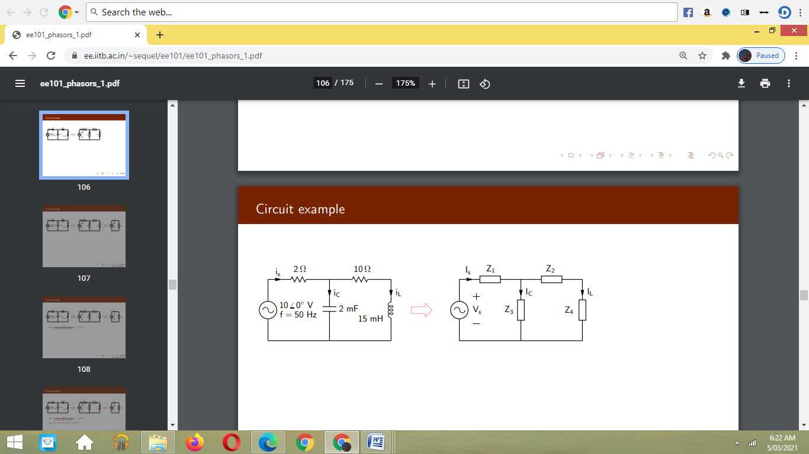 | L3 | CO2 | [7M]
 | b) | A coil of inductance 0.1H and resistance of 10Ω is connected in series with a capacitor of 0.1µF. Find frequency of resonance of the circuit. Also find quality factor of the circuit at resonance. | L3 | CO2 | [7M]
3. | a) | Write the procedure to analyze a parallel magnetic circuit. | L3 | CO3 | [7M]
 | b) | The number of turns in a coil is 250. When a current of 2A flows in this coil, the flux in the coil is 0.3mWb. When this current is reduced to zero in 2 milliseconds, the voltage in a coil lying in the vicinity of the coil is 63.75V. If the Coefficient of coupling between the coils is 0.75, find the self inductances of two coils, mutual inductance and number of turns in the second coil. | L4 | CO3 | [7M]
4. |  | State and prove the Maximum Power Transfer Theorem, when the load impedance is the complex conjugate of the source impedance. | L4 | CO4 | [14M]
5. | a) | Briefly explain the Z and ABCD two port network parameters. | L2 | CO5 | [7M]
 | b) | 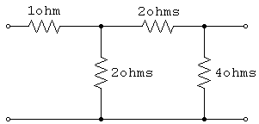  Find the Y-parameters for the network shown in Figure below | L3 | CO5 | [7M]
6. | a) | A series RLC circuit consists of a resistance 20Ω, inductance 0.05H and capacitance 20µF in series with a 100V constant voltage source when the switch is closed at t=0, find the expression for the current in the circuit. Also find the current at t=3ms. | L3 | CO6 | [7M]
 | b) | Derive the expression for voltage and current of series RC circuit (source free) and plot the decay of voltage and current. | L2 | CO6 | [7M]
7. | a) | What do you mean by super node analysis? Consider a suitable circuit on your own and explain super node analysis on that. | L2 | CO1 | [5M]
 | b) | An impedance Z₁=(10+j10)Ω is connected in parallel with another impedance of resistance 8.5Ω and a variable capacitance connected in series. Find C such that the circuit is in resonance at 5Hz. | L3 | CO2 | [5M]
 | c) | Explain statically and dynamically induced emfs. | L2 | CO3 | [4M]
8. | a) | What is the necessity of using network theorems when Ohm’s Law and Kirchhoff’s Laws can be used to solve any given electric network? | L5 | CO4 | [5M]
 | b) | When do we say that, an electric network is symmetrical? What are the conditions for an electrical network to be symmetrical in terms of  (i) Y-parameters; (ii) Z-parameters; | L5 | CO5 | [5M]
 | c) | A RL circuit with R=100Ω and L=2mH is excited with an exponential input  v(t) = e^{20t}. Find the response i(t). | L3 | CO6 | [4M]

-- 00 -- 00 –

